Gaseous Stunning of Turkeys:
Can it be Harnessed for Halal Processing?

Ahmad Alabsy, Ph. D.
Halal Transactions of Omaha
Omaha, NE, USA

Abstract
Gas stunning has been applied on poultry (chicken and turkey) in several countries mostly to kill the birds before slaughtering them. This practice is gaining popularity among poultry processors mainly to satisfy the increasing demands of animal rights groups and governmental regulations, with little consideration for the requirements of ritual slaughter of both the Halal and Kosher. Since the CAS is becoming widely spread in European countries and being introduced more recently in the US, a question arose, which is: can the CAS technology be adjusted to accommodate the Halal slaughtering protocols besides being humane? The objective of the current study was an attempt to answer this question. In various experiments, the CAS system was manipulated and applied on turkeys at two slaughtering plants in the USA. By adjusting the concentration of CO2 (which causes the stunning) in the gas mix, we found out that the birds were immobilized but still alive when reaching the kill knife, hence, they still possess the “Hayatul Mustaqirrah”, which could make the procedure both humane and Halal. Furthermore, this method of gaseous stunning, like that of electrical stunning, resulted in more bleeding of the birds with less blood shots in their muscles resulting in a better quality of meat which is favored by processors and consumers alike and is considered an added value to the Halal product, making it “Halalan Tayyiban”.

Introduction
Stunning of birds and animals before slaughtering has been recommended or even mandated by various authorities to minimize pain on the birds and animals during the process of handling and slaughtering, such as those of the Humane Methods of Slaughter Act of 1978 in the USA and the EU welfare strategy for the Protection and Welfare of Animals 2012. Even though there are provisions in these laws which exempt ritual slaughter from stunning, various extremist animal rights groups are pressuring legislatures in both regions to force stunning and even prohibiting the sales of un-stunned meats. Other voices call for mandatory labeling of the Halal and Kosher meats sold in their domestic markets. Several countries such as Sweden, Norway, Iceland, Switzerland and Denmark have already passed laws prohibiting slaughtering without pre stunning. At the international level, the World Organization for Animal Health has guidelines on animal welfare and ritual slaughter.
There are two basic technological approaches to stunning—electrical stunning and gaseous stunning. Electric stunning is achieved by wetting the birds’ heads in water or a mist and creating a mild electrical circuit through it (for example 12-18V, 0.10 - 0.20Am, 200Hz for turkeys).
An alternative stunning system to the electrical water bath for poultry is the gas stunner, in which animals or birds are subjected to several variations of gas mixtures given to induce an anesthetic state. This is performed in either of two ways: by applying the Controlled Atmosphere Stunning (CAS) or the Low Atmospheric Pressure Stunning (LAPS). CAS method involves subjecting the birds to a gas mix of various concentrations of Carbon Dioxide (CO2), Oxygen (O2), Nitrogen (N) and/or Argon (AR). LAPS is applied by lowering the Oxygen concentration in a normal atmospheric air inside the stunning tunnel. In both cases, CO2 concentration is the controlling factor in the gas mixture depriving the birds of oxygen, causing them to lose consciousness. Both systems of stunning are claimed to eliminate the stress associated with de-crating and shackling of live birds which are usually associated with electrical stunning, thus reducing the number of broken bones and bruised muscles. The disadvantages of using the CAS or LAPS, however, are that CO2 can induce severe irritation to the bird’s throat and cause aversion, besides the high cost of installing the equipment and the increased chance of a system breakdown. A third method of stunning has been used on a limited scale by applying Carbon Monoxide (CO) on some fishes such as the Atlantic salmon. Carbon Monoxide, however, can cause death by poisoning not necessarily by asphyxia.
Halal certifiers, especially in Europe, have been scrambling to resist the new legislations or trying to cope with finding a middle ground that satisfies both the requirements for humane handling and those for Halal slaughter. The Food Standards Agency (FSA) animal welfare survey undertaken in abattoirs across Great Britain during one week in September 2013 showed around 84 per cent of animals slaughtered by the Halal method were stunned before slaughter. Several Muslim authorities have approved electric stunning for birds as long as the stunning does not kill the birds instantly and the birds can recover if removed from the line before cutting (Hayatul Mustaqirrah).

Until recently, almost all Islamic authorities have objected to the gas stunning because it was thought that gaseous stunning kills the birds with no chance of recovering. Some of these authorities have approved the CAS method if the birds tested positive for heart beats, but not necessarily recover fully if they are not slaughtered. The reactions to gaseous stunning among the religious authorities is apparently based on misinformation about the system or lack of scientific experimentation in adjusting the system to make it compatible with the the Halal requirements. In the present study, the author examined a CAS system closely by monitoring its application in two turkey slaughtering plants and experimented with calibrating the system to find ways to stun the birds without killing them.

Procedure
The present study was conducted on gas stunning practices at two turkey plants in the US during various times in 2012 and 2013. The two plants were utilizing the CAS system by applying the Praxair System, in which the live turkeys were placed in cages (crates) on a moving rail that passes through a chamber tunnel in which turkeys were subjected to a controlled mixture of gasses, including Carbon Dioxide (CO2), Carbon Monoxide (CO), Oxygen (O2), Nitrogen (N) and Argon (AR). The turkeys were passing through a tunnel of about 20ft long and emerging at the other end of it after 3-4 minutes, then continuing on for about one minute before reaching to the slaughtering mechanical knife. The Halal kill was performed mechanically using a fixed knife operated and backed up by a Muslim Blesser, who recited the prayer on each bird as they were being cut properly (the mechanical knife was making a transverse cut on the front side of the bird’s neck, cutting through the skin, trachea, esophagus and two main blood vessels). The bleeding time was about three minutes post slaughter during which the birds were bled and became completely dead before dipping them into the scolder.
The following conditions of gas treatment of the turkeys in the CAS system were studied:
- The stunning mechanism was adjusted in the control room in which the starting concentration of CO2 was about 75% then lowered in increments of 5% until reaching about 40%. The birds, both toms (males) and hens (females) were observed at each increment for any sign of life on the hanging rail before reaching the kill knife.
- After experimenting with the system for a while, a focus was made on three main mixtures of gases as follows:
- The mixture of gasses that contained CO2 at more than 60%, Nitrogen at about 30%, O2 at about 8% and Argon at about 0.4% (Gas Mix A).
- The mixture of gases that contained CO2 at 50-60%, O2 at about 8 % and Nitrogen and Argon making up the balance of 100% (Gas Mix B).
- The mixture of gases that contained CO2 at 40-50 % plus Nitrogen, Oxygen and Argon made up the balance of 100% (Gas Mix C).
- Few turkeys were slaughtered and observed without applying any stunning method for comparison with the three methods of stunning mixtures mentioned above.

The following observations were made to record any sign of life in turkeys that were subjected to the various conditions above and on the quality of their processed meats packed:
- Samples of the turkeys that were stunned by applying different gas mixes (Gas Mix A, B and C) were removed from the rail and examined for any sign of pulse or heartbeat. (Note: In Islamic tradition, the heart pulsing or lack of it has been used as a criterion to determine if the animal/bird is alive or dead- at the time of examination).
- Observations were made on all the turkeys as they emerged from the stunning tunnel to determine if they exhibited any other sign of life such as: flapping, twitching, eye movement, or totally recovering when removed from the line and placed on the floor.
- Observations were made on the presence of blood shots (spots) on the breast meats of the turkeys after processing them. (Note: The presence or absence of blood shots on the meat is one of the measures processors use to determine the quality and hence pricing of the meat).

Results & Observations

- The first method of treating turkeys inside the CAS chamber-tunnels with CO2 concentration in the gas mix at 60% or higher resulted in a complete suffocation (lack of enough oxygen), not poisoning, of the birds, which showed no movement after they emerged at the end of the tunnel. They also did not show any sign of heart beat or other signs of life, and apparently died of asphyxiation (choking). Also when some birds were removed from the rail and placed on the floor, they never recovered (Figure 1). The birds in this case were essentially dead by the time they reached the slaughtering knife and hence can be considered dead meat, similar to being dead on arrival (DOA).
- The second method of treatment, in which the CO2 concentration was lowered to 50 and 55% for hens and toms correspondingly resulted in a partial stunning of the turkeys which emerged at the end of the tunnel showing signs of life (Figure 1), including: eye blinking and heart beats, some wing flapping but without struggling movement. It is concluded that these birds were alive but unconscious and insensible to pain. When samples of these birds were taken off the rail and placed on the floor they fully recovered and walked away within about 4-7 minutes (Figure 2).
- The birds that were stunned at CO2 concentration of lower than 50% and those which were slaughtered without any stunning showed vigorous struggling movements and flapping while hanging on the rails.
- The breast meat of the processed turkeys described in these experiments were observed for blood spots and bruises, to compare the meat quality between the stunned birds (using the complete or partial stunning) versus the un-stunned birds. It is obvious from Figure 3 that the un-stunned birds had blood spots (also termed shots) on their breast meat compared to no discoloration in the muscles of the birds which were stunned by using any gas mix. Processors state that when the birds are not stunned they flap and struggle while hanging on the rail and during human handling, which results in blood accumulating in their body organs in addition to suffering bruises and broken bones in some cases. They also iterate that the stunned birds’ muscles become more relaxed where the blood flows out easier during bleeding and does not accumulate in the stiff muscles and viscera.

Conclusions & Recommendations
- The application of CAS on turkeys using high concentration of CO2 in excess of 60%, (Gas Mix A) resulted in the killing of the turkeys by suffocating them- asphyxia so the birds were all dead before reaching the kill knife. This makes the procedure unacceptable since the birds in this case will be considered dead meat (DOA), so their meat cannot be considered Halal according to most Halal authorities.
- Using a gas mix containing CO2 at less than 40% results in the birds being not immobilized and hence still fully awake and sensible, which makes the procedure at this gas mix not humane according to the Humane Handling and Slaughter Act.
- The gas mix which contained CO2 concentration of 50-60 % (depending on the size of the bird) was found to be the optimum mix for rendering the birds unconscious but alive, satisfying the requirements of both the humane handling from the animal welfare point of view and the Halal requirements.
- Different sizes of the same species of birds may require adjustment of the CO2 concentration to reach an optimum condition of stunning; i.e. 50% for the hens and 55% for the toms.
- We confirmed in these experiments what has been stated by other authors and meat processors that stunning of birds before bleeding results in more bleed out and hence less blood shots in their muscle meat. Such result is favored for a better quality of meat and a more desirable trait for Halal because of less blood retained in the carcass.
- We advise poultry companies interested in producing Halal poultry using the CAS system to consult with a Halal certification agency before operation. The certifier will advise the plant to make the necessary adjustment to the system through trial and error to reach the desired and optimal concentrations of gasses that will partially stun the birds to become insensible to pain without killing them before slaughter. This procedure may solve the impasse between the various parties (governments, animal right groups and religious organizations) since it satisfies all their stipulated requirements.
- We also advise the poultry companies who are applying the CAS system to:
- Check and fine-tune the operating system in the control room to ensure that the mechanism is running at an optimum condition. It is observed during these experiments that continuous tuning-up of the system and fixing any malfunction will also save the company money by cutting down on gas leaks and utilizing less of the expensive mixture of gasses.
- Observe the birds inside the stunning chamber remotely to make sure that they do not struggle too much or become dead on their first encounter with the gas mix.
- Keep records of the daily graph illustrating the gas mix in the stunning chamber throughout the entire kill shift (as shown in Figure 3).
- The author observed that using a manageable method of CAS at a moderate rate of CO2 concentration around 50-60% (Figure 5) produces comparable results to stunning the birds with a week electric current in a water bath. According to other researchers, the advantage of using the CAS system over electric stunning, however, is that gas stunning involves less human handling of the birds and less chance of drowning in the water bath.
- Based on the scientific findings in the present study, the author recommends approval of the controlled/monitored gas stunning system (CAS) which is supervised by a competent Halal Certifying Body to adjust and monitor the procedure. This study may help the religious authorities to make informed decision based on science and not outright reject it based on propaganda or false information. Also, it is important for informing the Halal Certifying Bodies in Europe to be a player in the meat industry in Europe amidst the controversies and to find a solution to the dilemma created by the extremist animal right groups and not be ‘shunned behind’.
- There is a progressive move among the US poultry processors to adopt the CAS system for stunning and processing of chickens and turkeys. The Halal certifiers need to be “ahead of the game” by working with the poultry industry in making the necessary adjustment to the system before outright rejecting it and then “losing the battle”. They should use the procedure instead of fighting it so they do not lose their right to practice ritual slaughter and produce the badly needed Halal meats to feed the Muslim masses around the World.

Further Readings:

Alabsy, A. 2003. Electrical Stunning of chickens. halaltrasnactions.org/stunning.

Benson, E.R., et.al. 2012. Evaluation of EEG based determination of unconsciousness. Veterinary Science 52:960-964.

Euro Parliament. 2012. Religious slaughter of animals in the EU. Europarl.europa.eu.

European Commission. 1998. The use of mixtures of the gases for stunning or killing poultry. Ec.europa.eu/food.

Grandin, T. and G.C. Smith. 2004. Animal welfare and humane slaughter. Grandin.com/references/humane slaughter, on line article

Grandin, T. 2013. Animal welfare evaluation of gas stunning (CAS) of chickens and other poultry. Grandin.com/humane slaughter, on line article.

Hoem, T. and J. Lankhaar. 1999. Controlled atmospheric stunning of poultry. Poultry Science 78:287-289.

Humane Slaughter Association. 2005. Gas killing of chickens and turkeys. Has.org.uk.

National Chicken Council. 2013. Brief on stunning of chickens. Nationalchickencouncil.org/, Washington, D.C.

Ovesen, H. S. Lindholst and M. Zanotti. 2006. Method and system for Gas stunning of poultry for slaughter. US Publication No. 7097552 B2.

Praxair Technology. CAS for turkeys. Praxairfood.com.

Raj, M. 1998. Welfare during stunning and slaughter of poultry. Poultry Science 77: 1815-1819.

Secci, G., et.al. 2015. Carbon monoxide as stunning/killing method on farmed Atlantic salmon Society of Chemical Industry, DOI: 10.1002/jsfa.7362.
The Food Standards Agency. Animal welfare survey undertaken in abattoirs across Great Britain during one week in September 2013. Food Standard Agency (FSA), UK.
The Guardian. 2014. What does Halal method of animal slaughter involve? theguardian.com/lifeandstyle/halalslaughter.

The National World. 2011. Bardot group campaigns against halal animal slaughter. thenationalworld/bardotgroupcampains.

The Poultry Site. 2013. EU regulation changes views on stunning at slaughter.
The poultrysite.com.

Velarde, A. et.al. 2014. Religious slaughter: Evaluation of current practices in selected countries. Meat Science 96: 278-287.

Wikipedia. Inert gas asphyxiation. Wikipedia.org.

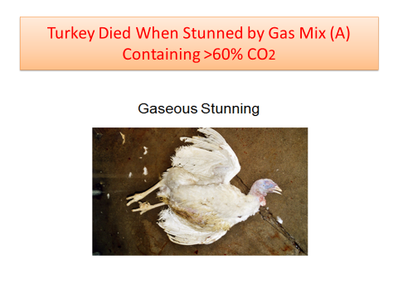
Figure 1. A turkey never recovered from stunning with Gas mix A

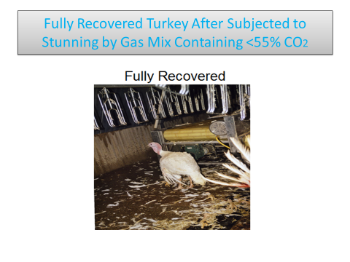
Figure 1. A turkey recovered completely from stunning with Gas mix B

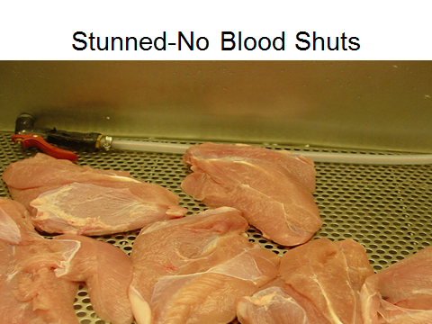

Figure 4. Breast Meat of turkeys stunned before slaughter, showing less blood shots.

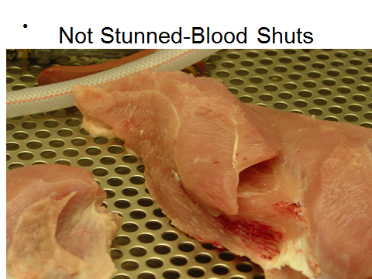

Figure 5. Breast meat of a turkeys that were not stunned before slaughter, showing more blood shots.

Figure 3. Chart showing an 8 Hour work shift during which turkeys were stunned in the CAS system at CO2 concentration of about 55%.

